ORDER BY, GROUP BY
ORIGINAL TABLE:
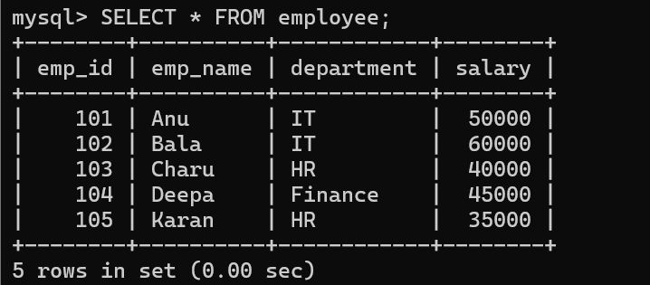
ORDER BY (ASC):
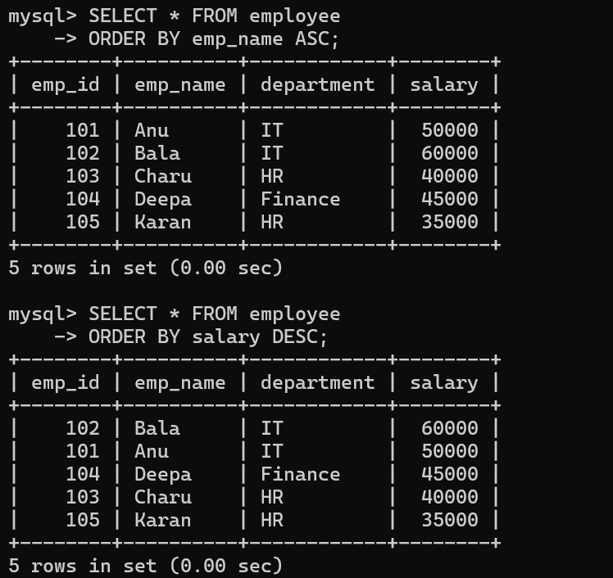

ORDER BY(DESC):


ORIGINAL TABLE:
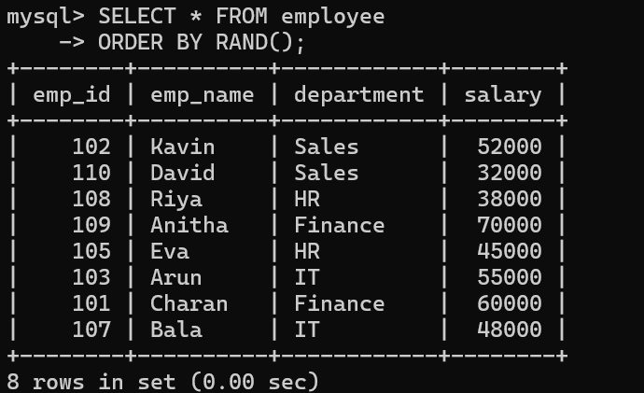
Employees grouped by department
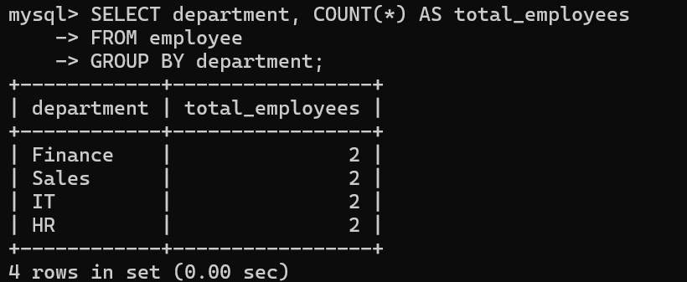
GROUP BY Average Salary
